VPC TASK2

- Create one VPC, with 1 public subnet and 1 private subnet
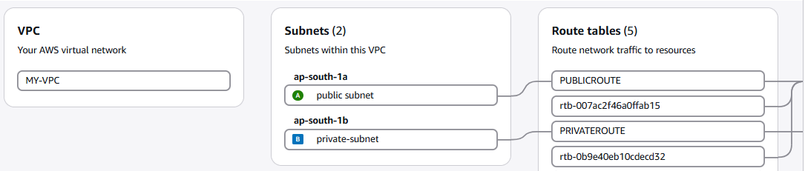
- Enable VPC peering for cross-region.
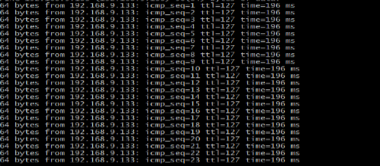
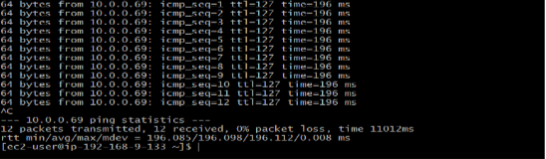
- Enable VPC peering for cross-account (you can collaborate with your friend to do this task).
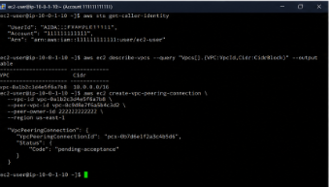
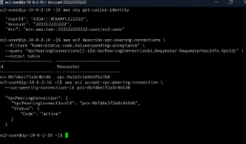

- Set up a VPC Transit Gateway.

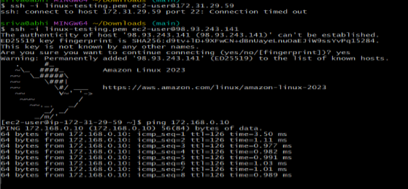

- Set up a VPC Endpoint
